ASSIGNMENT-10.4
Course: AI Assisted coding
Name: Ch.Shreevidya
HT NO: 2403A51419
Batch- 16

Task 1:
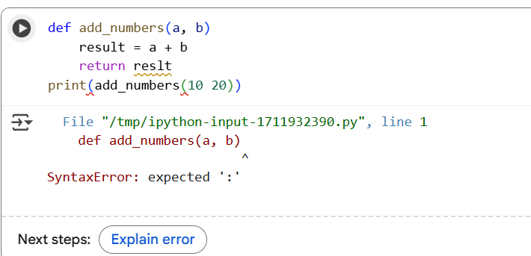
Corrected code & output:
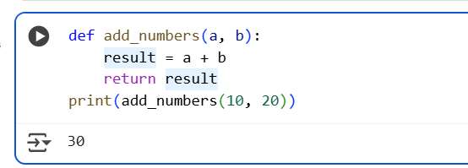
Explanation of code fixing:
SyntaxError: invalid syntax: This was because there was a missing colon (:) at the end of the function definition line def add_numbers(a, b). Python requires a colon to indicate the start of a code block, like a function body.
NameError: name 'reslt' is not defined: This error occurred in the return reslt line. You had a typo and wrote reslt instead of result. The variable storing the sum was named result.
TypeError: add_numbers() takes 2 positional arguments but 3 were given: This was in the print(add_numbers(10 20)) line. The numbers 10 and 20 were not separated by a comma, so Python interpreted 10 20 as a single argument instead of two separate arguments.
Task 2:
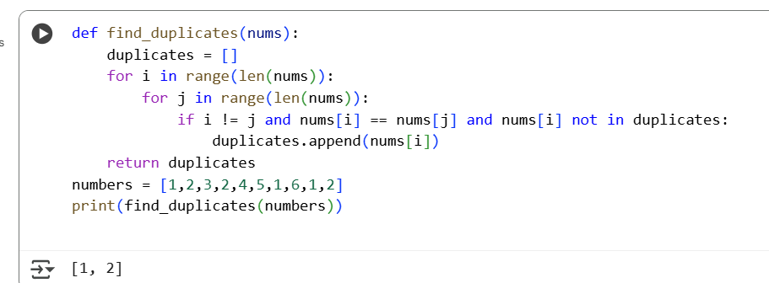

Efficient code & output:
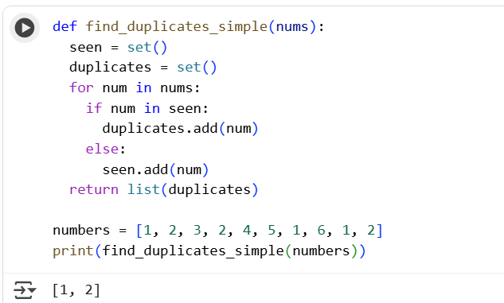
Explanation of Optimization:
In the original code (cell mW9vrfmjU3je), you used nested loops to compare each number with every other number. This is like checking every possible pair of numbers, which can take a long time as the list gets bigger.
In the optimized code, we use a set called seen. Sets are designed for fast lookups. When we iterate through the numbers, we quickly check if a number is already in the seen set.
Task 3:
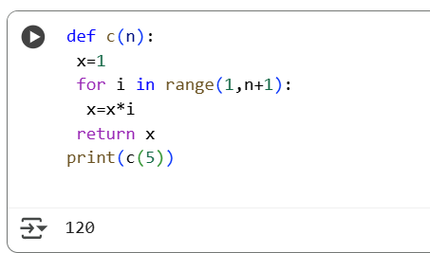
Prompt:
please convert the code into more readable version like with doc strings and function renaming.
Code&Output:
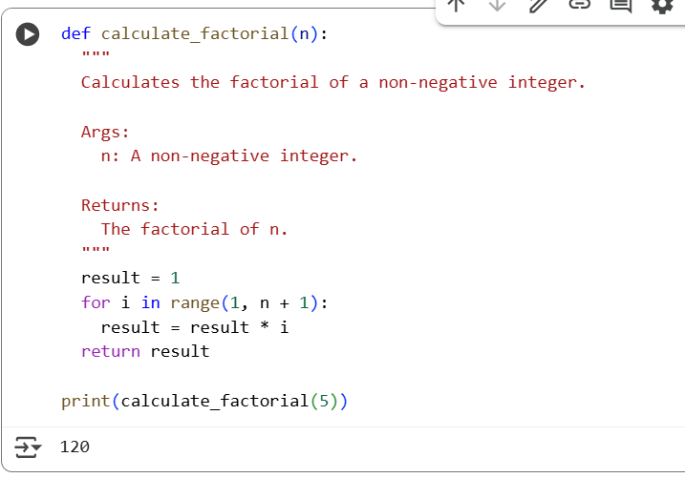

Task 5:
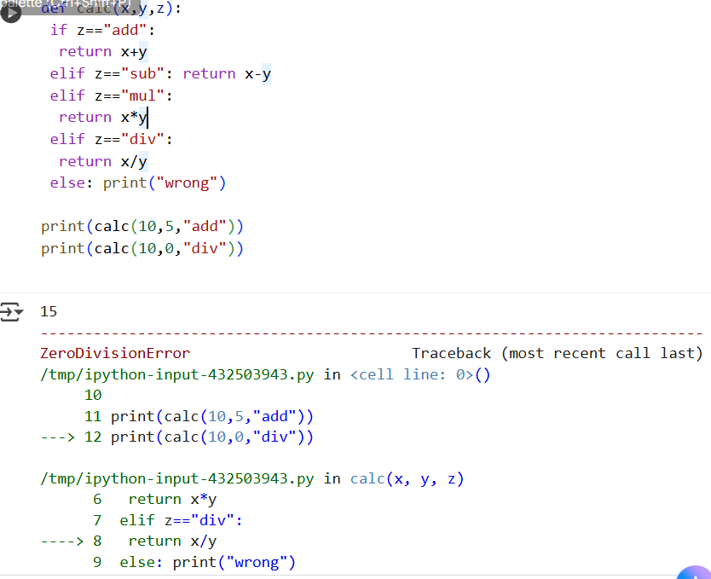
Code Review Report
- Missing Docstrings: The function calc lacks a docstring. Docstrings are important for explaining what a function does, its arguments, and what it returns.
- Inconsistent Formatting: There is inconsistent formatting in the code. For example, the return statements have varying indentation and some are inline. This makes the code harder to read and maintain.
- Missing Error Handling for Division by Zero: Although there's a basic check for division by zero, the function still raises a ZeroDivisionError if the denominator is 0. A more robust approach would be to handle this error gracefully, perhaps by returning None or raising a custom exception.
- Non-descriptive Function/Variable Names: The function name calc and the variable names x, y, and z are not very descriptive. Using more meaningful names would improve code readability.
- Suggestions for Readability and PEP 8 Compliance:
  - Add a docstring to the calc function explaining its purpose, arguments, and return values.
  - Apply consistent indentation (4 spaces) throughout the function body.
  - Place each return statement on its own line.
  - Use more descriptive names for the function and its parameters (e.g., perform_operation(num1, num2, operation)).
  - Consider using a dictionary to map the operation strings to the corresponding arithmetic functions, which can make the code more concise and readable.
  - Implement proper error handling for division by zero, perhaps by using a try-except block or returning a specific value like None or float('inf').

